

**Shenton College**

**Semester 1 Examination, 2016**

**Question/Answer Booklet**

|  |  |
| --- | --- |
| **Your marks** | **Marks**  **available** |
|  | 50 |
|  | 59 |
|  | 60 |
|  | **169** |
| % |  |

### CHEMISTRY

### 

**ATCHE – Year 12 – ATAR**

Student Name ________________________________

TEACHER

BARKER LEE SMITH

#### Time allowed for this paper

Reading time before commencing work: ten minutes

Working time for paper: two and a half hours

**Materials required/recommended for this paper**

To be provided by the supervisor

This Question/Answer Booklet

Multiple-choice Answer Sheet

Chemistry Data Sheet

***To be provided by the candidate***

Standard items: pens, pencils, eraser, correction fluid, ruler, highlighters

Special items: non-programmable calculators satisfying the conditions set out by the Curriculum Council for this course

**Important note to candidates**

No other items may be taken into the examination room. It is your responsibility to ensure that you do not have any unauthorised notes or other items of a non‑personal nature in the examination room. If you have any unauthorised material with you, hand it to the supervisor before reading any further.

**Structure of this paper**

|  |  |  |  |  |  |
| --- | --- | --- | --- | --- | --- |
| Section | Number of questions available | Number of questions to be answered | Suggested working time  (minutes) | Marks available | Percentage of exam |
| Section One:  Multiple-choice | 25 | 25 | 45 | 50 | 30 |
| Section Two:  Short answer | 12 | 12 | ~52 | 59 | 35 |
| Section Three:  Extended answer | 6 | 6 | ~53 | 60 | 35 |
|  | | | | | 100 |

**Instructions to candidates**

1. The rules for the conduct of Western Australian external examinations are detailed in the *Year 12 Information Handbook 2012.* Sitting this examination implies that you agree to abide by these rules.

2. Answer the questions according to the following instructions.

**Section One**: Answer **all** questions on the separate Multiple-choice Answer Sheet provided. For each question shade the box to indicate your answer. Use **only a blue or black pen** to shade the boxes. If you make a mistake, place a cross through that square, do not erase or use correction fluid, and shade your new answer. Marks will not be deducted for incorrect answers. No marks will be given if more than one answer is completed for any question.

**Sections Two and Three**: Write answers in this Question/Answer Booklet using **a blue or black pen**.

3. When calculating numerical answers, show your working or reasoning clearly unless instructed otherwise. Final answers should be to three significant numbers.

4. You must be careful to confine your responses to the specific questions asked and to follow any instructions that are specific to a particular question.

5. Spare pages are included at the end of this booklet. They can be used for planning your responses and/or as additional space if required to continue an answer.

* + Planning: If you use the spare pages for planning, indicate this clearly at the top of the page.
  + Continuing an answer: If you need to use the space to continue an answer, indicate in the original answer space where the answer is continued, i.e. give the page number. Fill in the number of the question(s) that you are continuing to answer at the top of the page.

**Section One: Multiple-choice 30% (50 Marks)**

This section has **25** questions. Answer **all** questions on the separate Multiple-choice Answer Sheet provided. For each question shade the box to indicate your answer. Use only a blue or black pen to shade the boxes. If you make a mistake, place a cross through that square, do not erase or use correction fluid, and shade your new answer. Marks will not be deducted for incorrect answers. No marks will be given if more than one answer is completed for any question.

Suggested working time for this section is 45 minutes.

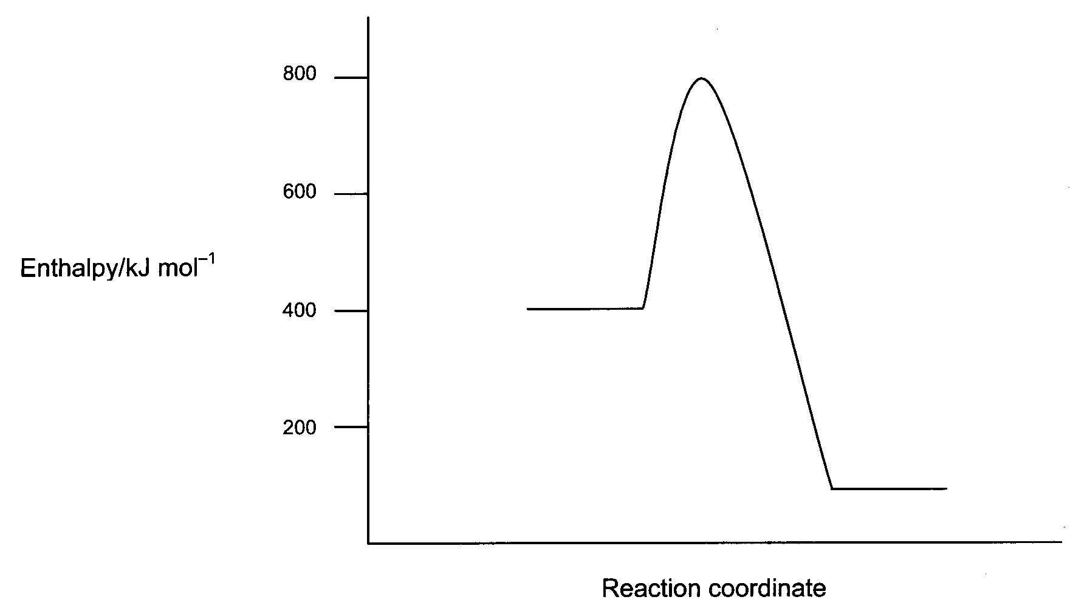Use the potential energy diagram shown below to answer question 1.

1. Which of the following gives the correct values for the enthalpy change (ΔH) and the activation energy (Ea) for the reverse reaction?

ΔH (kJ mol-1) Ea (kJ mol-1)

1. -300 +700
2. +300 +400
3. -300 +400
4. **+300 +700**
5. A catalyst was added to the reaction mixture. Comparing the catalysed reaction to the uncatalysed reaction, which of the following will remain the same?
6. **the enthalpy change of the reaction.**
7. the activation energy for the forward reaction.
8. the energy of the transition state
9. the activation energy of the reverse reaction.

Question 3 refers to the following graph, which represents the concentrations of SO2 and SO3 in the reaction shown below.

SO2(g) + NO2(g) SO3(g) + NO(g) ΔH = -42 kJ mol-1

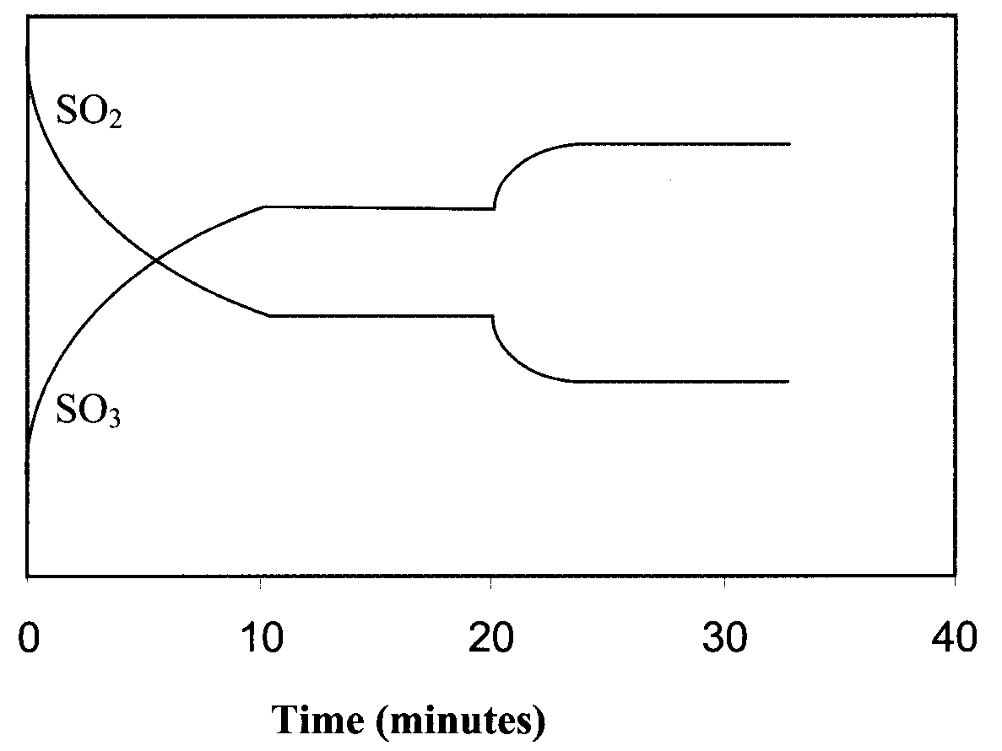

**Concentration**

1. At the 20 minute mark, what changes could have been made to the system to produce the effects shown on the graph?
2. The system temperature is increased or the concentration of NO is increased.
3. The system temperature is increased or the concentration of NO2 is increased.
4. **The system temperature is decreased or the concentration of NO is decreased.**
5. The system temperature is decreased or the concentration of NO2 is decreased.

1. If solid calcium carbonate is heated in a sealed container, the following equilibrium is established at 500°C and 600kPa pressure.

CaCO3(s) CaO(s) + CO2(g)ΔH = +178.3 kJ mol-1

Which of the following statements about this equilibrium is correct?

1. **Adding more CO2 to the system will reduce the amount of CaO present.**
2. Reducing the temperature of the system will increase the amount of CaO present.
3. Increasing the pressure of the system to 1000 kPa by adding inert nitrogen gas will decrease the amount of CaCO3 present.
4. Adding more CaCO3 to the system will cause an increase in CaO and CO2 present.
5. The next question refers to the chemical process shown below.

This process has reached equilibrium in a closed system.

Cr2O72-(aq) + H2O(l) ⇋ 2CrO42-(aq) + 2H+(aq)

A small amount of HCl(g) is added to the system and dissolved. Which of the following lists correctly shows the changes in **concentration** for H2O(l), CrO42-(aq) and Cr2O72-(aq) as equilibrium is re-established?

[H2O(l)] [CrO42-(aq)] [Cr2O72-(aq)]

1. increased decreased decreased
2. decreased increased increased
3. **unchanged decreased increase**
4. unchanged increased decrease
5. The following equation represents a closed equilibrium system.

2 O3 (g) ⮀ 3 O2 (g)

The value of K for this system at 2300 °C is 2.5 x 1012. This value tells us that;

1. The reaction is extremely exothermic
2. The reaction is extremely fast
3. **The reaction essentially goes to completion**
4. The reaction essentially does not occur

1. The reaction of iron(III) oxide with carbon monoxide gas is shown below:

Fe2O3(s) + 3 CO(g) ⇋ 2 Fe(l) + 3 CO2(g)

Which one of the following changes to the system will decrease the rate of the forward

reaction?

1. decreasing the volume of the reaction vessel
2. **decreasing the pressure of CO(g) in the vessel**
3. decreasing the Fe2O3(s) particle size
4. increasing the concentration of CO2(g) in the system
5. When pure water is kept in the fridge, the pH rises above 7. This is because;
6. The water has become slightly basic
7. There is a higher concentration of OH- ions than H3O+ ions
8. **The self-ionisation of water occurs to a lesser extent**
9. The value of Kw is higher
10. What is the conjugate base of HC2O4-?
11. **C2O42-**
12. H2C2O4
13. H3C2O4+
14. H2C2O4-
15. Which of the following pairs of words best describe the acidic properties of a 0.005 mol L-1 solution of H2CO3?
16. Dilute, strong
17. **Dilute, weak**
18. Concentrated, strong
19. Concentrated, weak

Use the information in the table below to answer questions 11 and 12.

|  |  |  |
| --- | --- | --- |
| **Indicator** | **Colour (low pH – high pH)** | **pH range** |
| Methyl yellow | Red – yellow | 2.4 – 4.0 |
| Bromocresol purple | Yellow – purple | 5.2 – 6.8 |
| Phenol red | Yellow – red | 6.8 – 8.4 |
| Cresol red | Yellow – red | 7.2 – 8.8 |

1. Which indicator in the table above would be most suitable to identify the end point in a titration of hydrochloric acid solution against sodium carbonate solution?
2. Methyl yellow
3. **Bromocresol purple**
4. Phenol red
5. Cresol red
6. In an acid-base titration with an end point of pH 8.2, a chemist uses bromocresol purple as the indicator. The acid is added from the burette to the base in a conical flask and the base has an initial pH of 10.5.

What effect will this procedure have on the calculation of the unknown concentration for the base?

1. **The concentration calculated will be higher than its true concentration.**
2. The concentration calculated will be lower than its true concentration.
3. The concentration calculated will be accurate.
4. A calculation cannot be done as no colour change will be seen during the titration.
5. Sodium oxide (Na2O) is a strong base, while sodium carbonate (Na2CO3) is a weak base. If an equal number of moles of each solid was placed into separate beakers containing 100 mL water, which of the following would be correct?
6. The beaker containing sodium oxide would have a lower pH
7. **Both beakers would contain the same concentration of sodium ions**
8. Both beakers would contain the same concentration of hydroxide ions
9. The sodium carbonate would not have dissolved as it is insoluble
10. When freshly cleaned aluminium metal is placed in dilute hydrochloric acid, a redox reaction occurs. Which of the following statements regarding the reaction is **NOT** correct?
11. **The pH of the reaction mixture would fall as the reaction proceeded**
12. The aluminium metal would be oxidised to form aluminium ions
13. The hydrogen ions would be reduced to form hydrogen gas
14. The gas formed would be positive for the ‘pop test’
15. Which of the following would be classified as basic substances?
16. NaOH
17. NH3
18. Na2CO3
19. CH3COOH
20. H2CO3
21. **(i), (ii) and (iii)**
22. (i), (iii) and (iv)
23. (i) and (iii)
24. (ii) and (v)
25. In which of the following equations is water acting as a Bronsted-Lowry base?
26. HCO3- (aq) + H2O (l) → CO32- (aq) + OH- (aq)
27. SO42- (aq) + H2O (l) → OH- (aq) + HSO4- (aq)
28. ClO- (aq) + H2O (l) → HClO (aq) + OH- (aq)
29. **H2PO4- (aq) + H2O (l) → H3O+ (aq) + HPO4- (aq)**
30. Which solution would have the highest pH?
31. 1 mol L-1 HNO3
32. 1 mol L-1 H2SO4
33. **1 mol L-1 H2CO3**
34. 1 mol L-1 HCl
35. Which of the following pairs of half-cells would produce the greatest voltage under standard conditions?
36. Pb / Pb2+ and Ag+ / Ag
37. Zn / Zn2+ and Ni2+ / Ni
38. Ni / Ni2+ and Pb2+ / Pb
39. **Zn / Zn2+ and Ag+ / Ag**
40. A beaker held a dilute solution of copper(II) sulfate. A piece of metal was added to the beaker. Slowly the blue colour of the solution faded and a salmon pink metal began to precipitate. Which of the following metals would **not** cause these observations?
41. Magnesium
42. Iron
43. Nickel
44. **Silver**
45. If you had an equal mass of each of the metallic ions below, which would require the greatest number of moles of electrons to be reduced to the elemental metal?
46. **Mn2+**
47. Ni2+
48. Cd2+
49. Co2+
50. In which of the substances below is the underlined element in an oxidation state of +3?
51. HClO2
52. C2H2O4
53. H2SO3
54. N2O3
55. HPO2
56. (i), (ii) and (iv)
57. (i), (iv) and (v)
58. (ii), (iii) and (iv)
59. **(i), (ii), (iv) and (v)**
60. In which of the following is chlorine in the highest oxidation state?
61. HClO
62. **Cl2O7**
63. HCl
64. ClO2
65. In which of the following reactions is oxygen reduced?
66. **F2O to O2**
67. H2O to H2O2
68. SO2 to SO3
69. H2O2 to O2
70. Which of the following is the strongest oxidant (oxidising agent) under standard conditions?
71. Cl2 (g)
72. **KMnO4 (aq) / H+ (aq)**
73. Br2 (l)
74. Na2Cr2O7 (aq) / H+ (aq)
75. Which of the following statements regarding redox reactions are true?
76. A reductant (reducing agent) will gain electrons
77. The oxidation number of the reductant (reducing agent) will increase
78. Oxidation numbers correspond to the number of electrons being transferred during a reaction
79. Oxidation cannot happen without reduction
80. Redox reactions always involve the transfer of electrons
81. (i), (iii) and (v)
82. **(ii), (iv) and (v)**
83. (i), (ii) and (iv)
84. (ii), (iii) and (iv)

**End of Section One**

**Section Two: Short answer 35% (59 Marks)**

This section has **twelve (12)** questions. Answer **all** questions. Write your answers in the space provided.

Spare pages are included at the end of this booklet. They can be used for planning your responses and/or as additional space if required to continue an answer.

* + Planning: If you use the spare pages for planning, indicate this clearly at the top of the page.
  + Continuing an answer: If you need to use the space to continue an answer, indicate in the original answer space where the answer is continued, i.e. give the page number. Fill in the number of the question(s) that you are continuing to answer at the top of the page.

Suggested working time for this section is 52 minutes.

**Question 26 (1 mark)**

|  |  |
| --- | --- |
| Equation | NH3(g) + H2O(l)  NH4+(aq) + OH-(aq) |
| Equilibrium constant expression | **K = [NH4+] [OH- ] 1 mark**  **[NH3]** |

**Question 27 (4 marks)**

An equilibrium is set up in a test tube by suspending some finely divided copper sulphide in a dilute solution of hydrochloric acid. The equation for the equilibrium is:

CuS(s) + H+(aq)  Cu2+(aq) + HS-(aq)

Complete the following table, giving your answers as “increases”, “decreases” or “no change”.

|  |  |  |
| --- | --- | --- |
| **Change made to the equilibrium system** | **Immediate effect on rate of forward reaction** | **Effect on equilibrium yield of HS- (aq)** |
| HC acid is passed into the solution | **increased** | **increased** |
| CuSO4 solution is added |  | **decreased** |
| More finely divided CuS is added | **no change** |  |

**Question 28 (7 marks)**

Ammonia is an industrially important gas produced by the Haber process, as illustrated by the equation below:

N2(g) + 3H2(g)  2NH3(g) ΔH = - 92 kJ mol-1 (at 25°C)

The reaction is catalysed by iron (III) oxide, Fe2O3.

The following graph shows the partial pressures of the three species involved in the reaction:

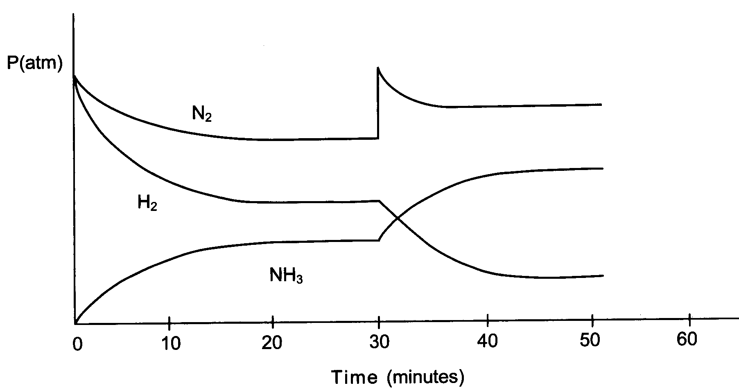

1. At the start, why does the partial pressure of the H2 gas decrease more rapidly than that of N2 gas? (1 mark)

**3 mol of Hydrogen will be consumed with 1 mol of nitrogen 1 mark**

**(must mention mole ratio)**

1. What has occurred at the 30 minute mark to cause the changes shown in the graph?

(1 mark)

**Concentration of N2 increased (or increased partial pressure of N2) 1 mark**

1. By the 45 minute mark, what difference will the change imposed at the 30 minute mark have made to the rate of:

(i) the forward reaction? **increased 1 mark**

(ii) the reverse reaction? **increased 1 mark** (2 marks)

At 50 minutes, the contents of the reaction vessel are rapidly compressed by reducing the volume. The changes in the partial pressures of the species are shown on the following graph, starting at 40 minutes.

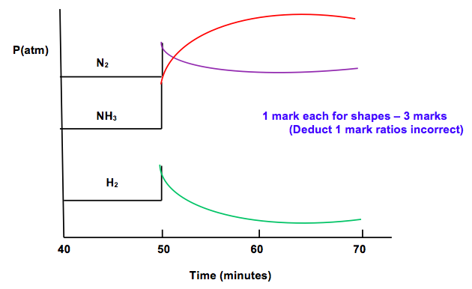

1. Complete the graph above up to 70 minutes by showing how the partial pressures of each species change as a new equilibrium is achieved. (3 marks)

**Question 29 (3 marks)**

Methanol gas [CH3OH] can be manufactured by combining hydrogen gas and carbon monoxide gas in an exothermic equilibrium reaction.

The equation for this reaction that reflects all the information given above.

2H2(g) + CO(g) ⇋ CH3OH(g) + heat

1. List one condition that would favour a fast reaction rate and one condition that would favour a high yield of methanol gas in an industrial setting. (2 marks)

|  |  |
| --- | --- |
| Conditions for a fast reaction rate | Conditions for a high yield |
| **Catalyst**  **High Temperature**  **High Pressure/Concentration of reactants** | **Low temperature**  **High Pressure**  **Remove CH3OH as it forms** |

1. What temperature conditions would suit this reaction in an industrial setting? (1 mark)

**Compromise temperature**

**Question 30 (2 marks)**

Write the equation for the reaction that occurs in each of the following procedures. If no reaction occurs, write ‘no reaction’. For full marks show only net ionic equations.

(a) Magnesium oxide solid is mixed with hydrochloric acid solution. (2 marks)

Equation: **MgO(s) + 2H+(aq) 🡪 Mg2+(aq) + H2O(l) 2 marks – reactants 1 mark**

**products 1 mark**

(b) Barium nitrate solution is mixed with sulfuric acid solution. (2 marks)

Equation: **Ba2+(aq) + SO42-(aq) 🡪 BaSO4(s) 2 marks – reactants 1 mark**

**products 1 mark**

**(states must be shown, no states – 1 mark ; valency wrong for ion – no mark; not ionic but correct molecular equation – 1 mark;**

**Question 31 (3 marks)**

Water ionises according to the equation H2O () H+ (aq) + OH– (aq)

At 25°C, Kw = 1.0 × 10­–14 mol2 L–2. At 50°C, the Kw value changes to approximately 5.5 × 10–14 mol2 L-2.

Use the information above, and Le Châtelier’s principle, to predict whether the self-ionisation of water is an endothermic or exothermic process. Explain.

**At 50 °C Kw value increases 🡪 higher concentration products than reactants1 mark**

**Higher temperature favours endothermic reaction 1 mark**

**forward reaction endothermic to favour products. 1 mark**

**(If they answer Exothermic – 0 marks altogether)**

**Question 32 (7 marks)**

1. 30.0 mL of a sodium carbonate solution is made up to 300 mL with distilled water. The resultant solution has a sodium carbonate concentration of 0.108 mol L-1. What mass of sodium carbonate was present in the original solution. (2 marks)

**ccVc = cdVd cc  = 0.300 x 0.108 = 1.08 mol L-1 1 mark**

**0.0300**

**n(Na2CO3) = c x V = 1.08 x 0.0300 = 0.0324 mol**

**m(Na2CO3) = n x M = 0.0324 x 105.99 = 3.43 g 1 mark**

1. 10.0 mL of a 2.00 mol L-1 H2SO4 solution is added to 10.0 mL of 1.50 mol L-1 NaOH. What is pH of the resultant solution? (5 marks)

**H2SO4 + 2NaOH → Na2SO4 + 2H2O**

**1 mol 2 mol 1 mol 2 mol**

**n(H2SO4) = cV = 2.0 x 0.01 = 0.020 mol 1 mark**

**n(NaOH) = cV = 1.5 x 0.01 = 0.015 mol**

**2 mol NaOH reacts with 1 mol H2SO4**

**0.015 mol NaOH reacts with 0.0075 mol H2SO4**

**excess H2SO4 = 0.0125 mol = 0.025 mol H+ 1 mark**

**Volume is additive so V = 0.020 L 1 mark**

**c(H+) = n = 0.025 = 1.25 mol L-1 1 mark**

**V 0.020**

**pH = -log[H+] = -log(1.25) = -0.0969 1 mark**

**Question 33 (8 marks)**

There are many different theories used to describe acids and bases, such as Arrhenius, Bronsted-Lowry and Lewis.

1. Define an acid and a base according to the Bronsted-Lowry theory. (2 marks)

**Acid is proton donor**

**Base is proton acceptor**

Consider the following acid-base reaction.

H2PO4- (aq) + H2O (l) ⮀ H3O+ (aq) + HPO42- (aq)

**A** B CA **CB**

1. Label the conjugate acid-base pairs in the reaction above. (2 marks)
2. The HPO42- ion is a weak base according to the Bronsted-Lowry theory. Write an equation showing how this ion behaves as a base in aqueous solution. (2 marks)

**HPO42- + H2O ⮀ H2PO4- + OH-** **(1) correct eq, (1) double arrows**

1. H2PO4- has a Ka value of 6.2 x 10-8. Explain why this value makes H2PO4- a weak acid (2 marks)

**A very small Ka indicates that the reactants are very much favoured. (1)**

**Only a small amount of product is created, only slightly ionised = weak acid. (1)**

**Question 34 (5 marks)**

A variety of substances are listed below. Use these substances to answer the following questions. Not all substances must be used, but each substance can only be used **once**.

Na2CO3 Na H3PO4 NaCl

Au H2SO4 NaH2PO4 Cu

CuCl2 Na2SO4 Ni

1. Which two substances could be mixed together to form a buffer? (1 mark)

**H3PO4 and NaH2PO4**

1. Using an equation, explain what happens when OH- is added to the buffer mixture.

(2 marks)

**H3PO4 + H2O 🡨🡪 H3O+ + H2PO4-**

**Added OH- will react with the H3O+ H3O+ + OH- 🡪 2H2O**

1. Which substance could be classified as a ‘basic salt’? Write a hydrolysis equation to

support your answer. (2 marks)

**Na2SO4**

**SO42- + H2O ⮀ HSO4- + OH-**

**(OR Na2CO3 / Na3PO4 if part a) / b) incorrect)**

**Question 35 (6 marks)**

A sample of copper (II) iodide powder was dissolved in water. This solution was then split into three (3) test tubes and a separate reaction was performed in each.

1. Chlorine gas was bubbled through the first test tube. Write the oxidation and reduction half-equations for the reaction that would have taken place. (2 marks)

oxidation: **2 I- (aq) → I2 (aq/s) + 2e-**

reduction: **Cl2 (g) + 2e- → 2 Cl- (aq)**

1. Zinc metal was added to the second test tube. Describe the predicted observations for this reaction. (2 marks)

**A silver metal corrodes in blue solution, blue solution fades to colourless as salmon pink metal forms**

Lead(II) nitrate was added to the third test tube and the molecular equation for the reaction that took place is shown below.

CuI2 (aq) + Pb(NO3)2 (aq) → Cu(NO3)2 (aq) + PbI2 (s)

1. Is this a redox reaction? Explain your answer. (2 marks)

**No**

**There is no change in oxidation number for any species**

**Question 36 (2 marks)**

Write a balanced half equation for the following:

NO3- 🡪 NO

**NO3- + 4H+ + 3e- 🡪 NO + 2H2O**

**Question 37 (11 marks)**

The following diagram shows how a car battery which is used to produce a voltage.

Both electrodes in a car battery are lead-based and the electrolyte in the cell is sulfuric acid. The reactions occurring at each electrode are also indicated in the diagram.

**Cathode 1**

V

H2SO4 (aq)

PbO2 / PbSO4

Pb / PbSO4

PbO2 + SO42- + 4 H+ + 2 e- →

PbSO4 + 2 H2O

Pb + SO42- → PbSO4 + 2 e-

**🡪 1**

**Anode 1**

1. On the diagram above label the cathode and anode, and label and show the direction of electron flow and the direction of cation flow. (3 marks)
2. Write the overall equation for the discharging process. (1 mark)

**Pb + 2 SO42- + PbO2 + 4 H+ 🡪 2 PbSO4 + 2 H2O 1 mark**

1. Identify the oxidant (oxidising agent) and reductant (reducing agent). Use oxidation numbers to support your answer. (3 marks)

**PbO2 is the oxidant and Pb is the reductant 1 mark**

**Pb (0) to (+2) It is oxidised, therefore the reductant 1 mark**

**Pb in PbO2 (+4) to (+2) It is reduced, therefore the oxidant 1 mark**

1. What is the function of the sulfuric acid electrolyte? (1 mark)

**Allow flow of current, in the form of ions, within cell 1 mark**

1. What would happen to the pH of the electrolyte as the battery discharges? Explain your answer. (2 marks)

**pH would rise 1 mark**

**H+ ions are consumed as battery discharges 1 mark**

1. Using your data sheet, calculate the overall voltage of this cell, under standard conditions (1 mark)

**0.36 + 1.46 = 2.05 V 1 mark**

**End of Section Two**

**Section Three: Extended answer 35% (60 Marks)**

This section contains **six (6)** questions. You must answer **all** questions. Write your answers in the space provided.

Spare pages are included at the end of this booklet. They can be used for planning your responses and/or as additional space if required to continue an answer.

* + Planning: If you use the spare pages for planning, indicate this clearly at the top of the page.
  + Continuing an answer: If you need to use the space to continue an answer, indicate in the original answer space where the answer is continued, i.e. give the page number. Fill in the number of the question(s) that you are continuing to answer at the top of the page.

Suggested working time for this section is 53 minutes.

**Question 38 (7 marks)**

The Pilbara iron ore industry uses vast amounts of ammonium nitrate explosive to break up the rock and ore. Much of the ammonium nitrate is produced in Kwinana, Western Australia, using the following process:

Step 1: Natural gas (from the North West Shelf) is reacted with steam.

CH4(g) + H2O(g) ⇋ 3H2(g) + CO(g)

Step 2: Hydrogen produced in the above process is reacted with nitrogen from the air using

the Haber Process.

3H2(g) + N2(g) ⇋ 2NH3(g)

Step 3: Ammonia is reacted with oxygen in air.

4NH3(g) + 5O2(g) ⇋ 4NO(g) + 6H2O(g)

Step 4: Nitrogen monoxide is reacted with oxygen in air.

2NO(g) + O2 (g) ⇋ 2NO2(g)

Step 5: The nitrogen dioxide produced in the reaction above is reacted with water and

oxygen to form nitric acid.

4NO2 (g) + 2H2O (l) + O2 (g) ⇋ 4HNO3(aq)

Step 6: Finally, nitric acid is reacted with ammonia to form ammonium nitrate.

HNO3 (aq) + NH3 (g) ⇋ NH4NO3(aq)

The equation for Step 3 of the process is reproduced below.

4NH3(g) + 5O2(g) ⇋ 4NO(g) + 6H2O(g)

It is an exothermic reaction (ΔH = −1130 kJ) and is carried out at 900°C and atmospheric pressure in the presence of a catalyst.

Use your understanding of reaction rates and equilibrium principles to explain why these conditions are employed for this reaction.

* **The forward reaction is exothermic, so would be favoured by low temperature**
* **Although low temperature favours the forward reaction, a moderate high enough temperature is used.**
* **The moderate high temperature used is a compromise between rate and yield.**
* **A catalyst is also introduced to speed up the reaction in both ways. A catalyst will however not influence the yield.**
* **There are 9 moles of gas on the LHS and 10 moles of gas on the right hand side; low pressure favours the forward reaction (marginally)**
* **The reactions will proceed reasonably well at atmospheric pressure. The difference in moles of gas on the left and right hand sides is not significant enough to justify the cost of lowering the pressure.**
* **High pressure favours high rate.**

**Question 39 (10 marks)**

A reaction that reaches equilibrium is studied in the laboratory. In this system, two colourless gases, nitrogen trichloride and oxygen, react to produce brown nitrogen dioxide gas and light green chlorine gas. The equation for the system is

2NCl3(g) + 2O2(g) ⇋ 2NO2(g) + 3Cl2(g)

1. State *three observable properties* that would stay constant when equilibrium is reached.

(3 marks)

**Colour, temperature, rate, yield, pressure (1 each)**

1. What is meant by the statement “dynamic equilibrium”. (2 marks)

**A system where reactions are still occurring (1)**

**even though no changes appear to be taking place. (1)**

1. Write the equilibrium constant expression for the system. (1mark)

**K = [NO2]2 [Cl2]3**

**[NCl3]2 [O2]2**

1. State the effect of an increase in the pressure on the yield of chlorine? Explain

(2 marks)

**Reduced yield.**

**LCP predicts that an increase in pressure will try to reduce pressure. The side with less moles will be favoured, LHS.**

1. Complete the graph below to show what happens to the concentration of chlorine after the pressure was increased.

(2 marks)

Conc

(mol L-1)

Cl2

Time

**Question 40 (12 marks)**

An electrochemical cell consists of a tin electrode in a solution of 1.0 mol L-1 tin(II) nitrate, to

create a Sn/Sn2+ half cell, and a similarly constructed half cell composed of a chromium

electrode in a solution of 1.0 mol L-1 chromium(III) nitrate. The two electrodes are joined by a

piece of copper wire. A salt bridge, as shown in the diagram below, joins the two solutions.

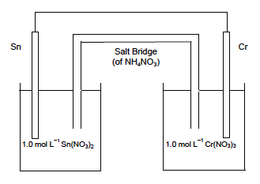

**🡨 e-**

**+ 🡨**

**ANODE**

1. On the diagram, label (3 marks)

(i) the anode

(ii) the direction of electron flow

(iii) the direction of cation flow in the salt bridge.

1. Write the balanced anode and cathode reactions. (2 marks)

(i) Anode: **Cr 🡪 Cr3+ + 3e-**

(ii) Cathode: **Sn2+ + 2e- 🡪 Sn**

1. Would sodium carbonate be suitable as a salt for the salt bridge? Explain. (2 marks)

**No.**

**CO32- ions would react with Sn2+ and Cr3+. This would prevent the flow of ions in the salt bridge.**

1. Why does the rate of production of electrical current from an electrochemical cell decrease as it operates? (1 mark)

**The concentration of solution decreases.**

1. During the operation of an electrochemical cell, why is it important that the anode and cathode do not come into contact with each other? (1 mark)

**If the anode and cathode contact, a reaction will occur on the anode. Electrons will not flow through the external circuit.**

1. Use E0 values to determine the theoretical emf of this cell? Show your working. (3 marks)

**Cr 🡪 Cr3+ + 3e- E0 = +0.76 V**

**Sn2+ + 2e- 🡪 Sn E0 = -0.14 V**

**E0 cell = 0.76 – 0.14 = 0.62 V**

**Question 41 (19 marks)**

The acidity of wine is due mainly to the presence of the **soluble salt** potassium tartrate (KC3H4O4COOH). It contains the tartrate ion which is a **weak monoprotic acid**. A student conducted an investigation to find the concentration of potassium tartrate in some red wine. To do this three 50 mL samples of wine were titrated with 0.0105 mol L-1 NaOH. The data recorded by the student is shown here.

|  |  |  |  |
| --- | --- | --- | --- |
| Volume of NaOH | First titration | Second titration | Third titration |
| Final reading (mL) | 9.80 mL | 10.30 mL | 10.20 mL |
| Initial reading (mL) | 0.05 mL | 0.20 mL | 0.10 mL |
| Volume used (mL) | **9.75 mL** | **10.1 mL** | **10.1 mL** |

1. Write the formula for the **tartrate ion** present in potassium tartrate (KC3H4O4COOH).

(1 mark)

**C3H4O4COOH-**

1. With reference to the information given write an ionisation or hydrolysis equation for the  
   tartrate ion? (2 marks)

**C3H4O4COOH- + H2O 🡪 C3H4O4COO2- + H3O+ or**

**C3H4O4COOH- 🡪 H+ + C3H4O4COO2-**

1. Use the information given to write a NET IONIC equation for the reaction occurring between the tartrate ion and sodium hydroxide solution? (2 marks)

**C3H4O4COOH- + OH- 🡪 C3H4O4COO2- + H2O**

1. Name the apparatus used to measure the wine samples and the sodium hydroxide samples. State what is used for the final rinse of the apparatus? (4 marks)

Wine sample measured with **Pipette**

Apparatus rinsed with **Wine sample**

Sodium hydroxide sample measured with **Burette**

Apparatus rinsed with **NaOH**

1. Use the data in the table to find the average volume of NaOH used. (2 marks)

**Leave out 9.75**

**Average = (10.1 + 10.1)/2 = 10.1 mL**

1. Calculate the percentage of potassium tartrate in the wine. (4 marks)

(Assume the wine has a density of 1g per mL)

**n(NaOH) = cV = 0.0105 x 0.0101 = 0.00010605 mol**

**C3H4O4COOH- + OH- 🡪 C3H4O4COO2- + H2O**

**n(C3H4O4COOH-) = n(NaOH) = 0.00010605 mol**

**m(C3H4O4COOH-) = nM = 0.00010605 x 149.08 = 0.01581 g**

**% by mass = 0.01581/50 x 100 = 0.0316%**

(f) A solution of potassium tartrate (KC3H4O4COOH) can act as a buffer. Explain how a buffer could be made and how potassium tartrate would react with added H+ and OH-. Include equations. (4 marks)

**To make a buffer you need a weak acid and its conjugate base or a weak base and its conjugate acid.**

**C3H4O4COOH- is a weak acid and dissolves in water to make C3H4O4COO2-.**

**C3H4O4COOH- + H2O 🡪 C3H4O4COO2- + H3O+**

**When H+ is added, the C3H4O4COO2- will react to form C3H4O4COOH-**

**C3H4O4COO2- + H+ 🡪 C3H4O4COOH-**

**When OH- is added, the H3O+ will react to from H2O**

**H3O+ + OH- 🡪 2H2O**

**Question 42 (6 marks)**

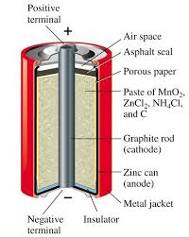The dry cell (Leclanche cell) is a commercial galvanic cell.

It has an outer casing of zinc, a carbon rod surrounded by a paste of MnO2 and an electrolyte paste of NH4Cl and ZnCl2

1. What is the role of the zinc casing? (1 mark)

**To create electrons as it corrodes.**

1. Write an equation for this reaction. (1 mark)

**Zn 🡪 Zn2+ + 2e-**

(c) The cathode reaction is 2 Mn02(s) + 2H+(aq) + 2e- 🡪 Mn2O3(s) + H2O(l)

Write the overall equation for this reaction. (1 mark)

Zn(s) + 2Mn02(s) + 2H+(aq) 🡪 Mn2O3(s) + H2O(l) + Zn2+

1. The H+(aq) ions for the cathode reaction of the dry cell are provided by the NH4+(aq) in the electrolyte paste. Write an equation to show how this occurs. (1 mark)

**NH4+ 🡪 NH3 + H+**

1. What is the role of the porous paper? (2 marks)

To keep the anode and cathode separated

To allow ions to transfer

**Question 43 (6 marks)**

Write separate half equations and an overall redox equation for the following reactions.

1. H2S (aq) + Cl2 (g) 🡪 S (s) + Cl- (aq)

**H2S 🡪 S + 2H+ + 2e-**

**Cl2 + 2e- 🡪 2Cl-**

**H2S + Cl2 🡪 S + 2H+ + 2Cl-**

1. MnO4- (aq) + C2O42- (aq) 🡪 Mn2+(aq) + CO2 (g)

**MnO4- + 8H+ + 5e- 🡪 Mn2+ +4H2O**

**C2O42- 🡪 2CO2 + 2e-**

**2MnO4- + 16H+ + 5C2O42- 🡪 2Mn2+ +8H2O + 5 CO2**

1. Zn (s) + VO3- (aq) 🡪 Zn2+ (aq) + VO2+ (aq)

**Zn 🡪 Zn2+ + 2e-**

**VO3- + 4H+ + e- 🡪 VO2+ + 2H2O**

**2VO3- + 8H+ + Zn 🡪 2VO2+ + 4H2O + Zn2+**

**END OF QUESTIONS**

**Spare Page**

_____________________________________________________________________________

______________________________________________________________________________________________________________________________________________________________________________________________________________________________________________________________________________________________________________________________________________________________________________________________________________________________________________________________________________

_____________________________________________________________________________

____________________________________________________________________________________________________________________________________________________________________________________________________________________________________________________________________________________________________________________

**Spare Page**

_____________________________________________________________________________

______________________________________________________________________________________________________________________________________________________________________________________________________________________________________________________________________________________________________________________________________________________________________________________________________________________________________________________________________________

_____________________________________________________________________________

____________________________________________________________________________________________________________________________________________________________________________________________________________________________________________________________________________________________________________________

**SHENTON COLLEGE**

**MULTIPLE CHOICE ANSWER SHEET**

# SUBJECT: Chemistry 12 ATAR

# NAME:_______________________________________________

DIRECTIONS:

1. USE ONLY A BLUE OR BLACK PEN TO SHADE THE BOXES.

2. MARK THE BOXES IN THE FOLLOWING WAY [A] [B] [C] [D].

3. IF YOU MAKE A MISTAKE, PLACE A CROSS THROUGH THAT SQUARE, DO NOT ERASE OR USE

CORRECTION FLUID, AND SHADE YOUR NEW ANSWER.

[A] [B] [C] [D].

4. PLEASE ENTER YOUR SURNAME OR STUDENT NUMBER IN THE BOXES AS DIRECTED BY YOUR

SUPERVISOR.

5. MORE THAN ONE ANSWER WILL INVALIDATE THE ANSWER.

6. YOUR ANSWER SHEET SHOULD BE PLACED INSIDE YOUR EXAM AT THE END.

|  |  |  |
| --- | --- | --- |
|  |  |  |
| 1 [A] [B] [C] [D] | 11 [A] [B] [C] [D] | 21 [A] [B] [C] [D] |
| 2 [A] [B] [C] [D] | 12 [A] [B] [C] [D] | 22 [A] [B] [C] [D] |
| 3 [A] [B] [C] [D] | 13 [A] [B] [C] [D] | 23 [A] [B] [C] [D] |
| 4 [A] [B] [C] [D] | 14 [A] [B] [C] [D] | 24 [A] [B] [C] [D] |
| 5 [A] [B] [C] [D] | 15 [A] [B] [C] [D] | 25 [A] [B] [C] [D] |
|  |  |  |
| 6 [A] [B] [C] [D] | 16 [A] [B] [C] [D] |  |
| 7 [A] [B] [C] [D] | 17 [A] [B] [C] [D] |  |
| 8 [A] [B] [C] [D] | 18 [A] [B] [C] [D] |  |
| 9 [A] [B] [C] [D] | 19 [A] [B] [C] [D] |  |
| 10 [A] [B] [C] [D] | 20 [A] [B] [C] [D] |  |